

**School of Graduate Studies**

**Department of Computer Science**

**Artificial intelligence**

Project I : **Expert system oil exploration**

Submitted by: Abrahim Abdo

ID: pgp/768/13

Submitted to: Dr. Abeba.B

21 September 2021

There are seven major conceptual steps involved in the complete commercial “Petroleum Product Life Cycle” (Figure 1). These steps are

**(1) Prospecting,**

**(2) Leasing or acquiring access,**

**(3) Drilling operations,**

(4) Developing and producing,

(5)Transporting,

(6) Processing and refining,

(7) Marketing and sales.

Of the seven steps listed above, the **first three** steps are called the “**exploration phase**” and the forth step is the **“production/extraction phase”.**

**(1) Prospecting,**

**Determination of seismic velocities** is an important first step in the processingof seismic data. Velocities are needed to process multiple coverage recordingsin order to obtain an image of the subsurface in the distance-time domain. Thecommon-reflection point method (Mayne, 1962) provides a multiplicity of wavetravel-path information which allows direct determination of velocities associated with such paths.

**Knowledge Base**When picking velocity spectra the geophy• sicist uses "extra knowledge", particularly geological and geophysical knowledge, for the removal of ambiguities. Available sources of information are generally a raw stack or a constantThe geological context is described in a simplified form by:1. major geological sequences defined by their time limits, a rough estimateof expected interval velocities and possibility, or not, of decrease ofstacking velocities (velocity inversions) in each zone. Note that it is notso much narrow velocity intervals that are required, but rather majorclassifications such as unconsolidated formations (1500 to 3000 m/s) ormedium compact formations (2000 to 5000 m/s).

velocity_spectruim= [uniform(1,9) for p in range(0,9)]

json_str = json.dumps(elocity_spectruim)

resp = json.loads(json_str)

distance=['A','B','C','D','E','F','G','H','I']

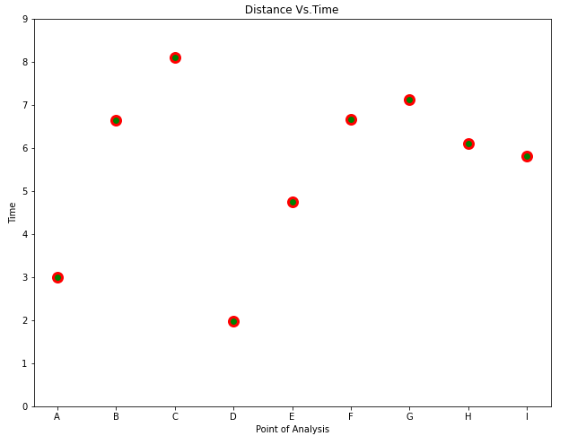2. time positions and the quality coefficient of some main seismic horizons.3. reference velocity function, if available. This data can be a velocity function obtained from a well or in previous surveys. In order to contributeto the consistency of the velocity functions along a profile, can use the velocity function determined in the previous analysis to limitthe search of the current analysis. This limiting is done only at the request of the user.

for i in range(0, 9):

t[i] = (500) / ((resp[i]+1000) * np.cos(7))

a = t[i]

b = t[i+1]

x[i] = (500+500*i)/(np.tan(7))

ch_of_t[i] = (t[i + 1]-t[i])

if ch_of_t[i] > 0:

vs[i] = (x[i])/(m.pow((2*t[i])*(ch_of_t[i]), 0.5))

c = vs[i]

d = vs[i+1]

e = ch_of_t[i]

f = ch_of_t[i+1]

T_of_x[i] = m.sqrt(

((m.pow(t[i], 2)) + (m.pow(x[i], 2)/(m.pow(vs[i], 2)))))

**Extraction Of A Velocity Function**

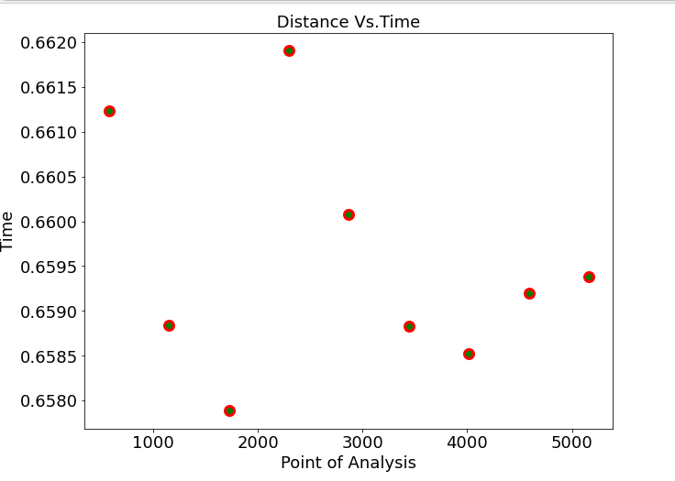

The velocity function versus time is obtained by appropriate picking of velocity spectrum extrema, called peaks, corresponding to primary reflections.The determination of the velocity field on a seismic line is achieved from thepicking of velocity spectra computed at various CDP locations

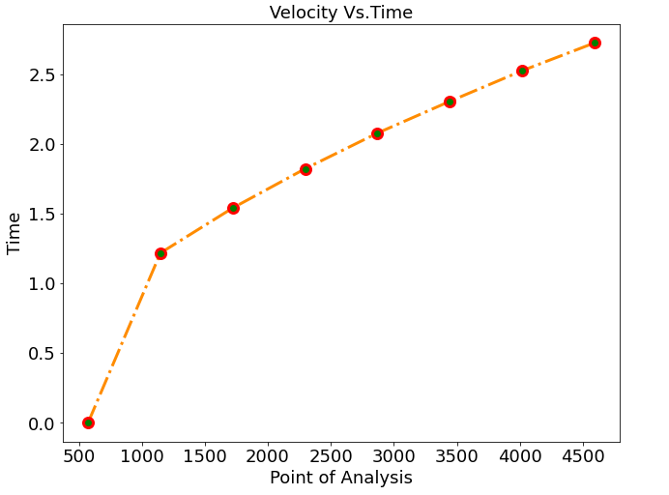

Partial pathways are eliminated using cumulative confidences. Thus only segments in continuous lines remain

**The Role of Geoscientists**

The majority of geoscientists employed in the search for oil and gas fall into one of three sub-specialties. Although there can be much overlap, these three sub-specialties are as follows:

* Geologists (understanding the rocks),
* Geophysicists (interpreting the subsurface structure or configuration through seismic, gravity, etc.) And
* Geochemists (understanding the subsurface fluids, like petroleum).

The information learned from the **appraisal is often applied to future projects**.

The challenge for **geoscientists** is to interpret the subsurface and for exploration the most important thing is the idea or concept of where hydrocarbons might be found in the subsurface and why.

**Geologists and geophysicists** try to predict where oil and gas occur by **“remote sensing”,**  
using

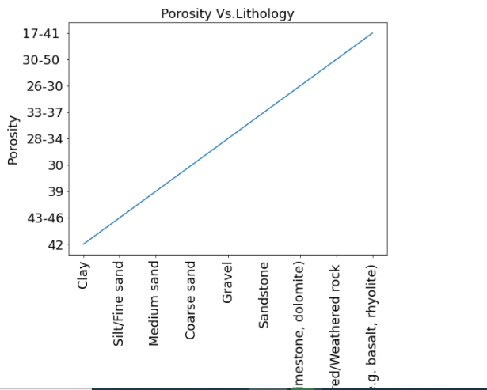

rock(sedimentary,1):-

structuer(siliceous),

depth(9,24),

occur_as(shale),

lithology(mudstone),

structuer(clastic),

* Gravity and magnetics,
* Rock distribution and properties, and
* Geophysical imaging tools to gather data on subsurface characteristics.

The data that are generated are typically subjected to computer processing, advanced modeling with three-dimensional (3-D) visualization in order to better understand and image the subsurface.

**Geochemists** study the chemistry of petroleum and its sources to characterize the petroleum type, history and origin. Geochemists also develop input into basin modeling which provides quantitative integrated petroleum system models, including source, reservoir, seal, trapping  
mechanism and hydrocarbon charge.

Two additional geologic specialty areas, **structural** geology and stratigraphy, are widely  
used in the oil industry.

* **Structural geology** provides an understanding of subsurface deformation processes that can create hydrocarbon traps.
* **Stratigraphy** is the study of the origin, composition, distribution, and succession of rock layers. Stratigraphers try to recognize and follow rock beds or layers from one well or outcrop to another.

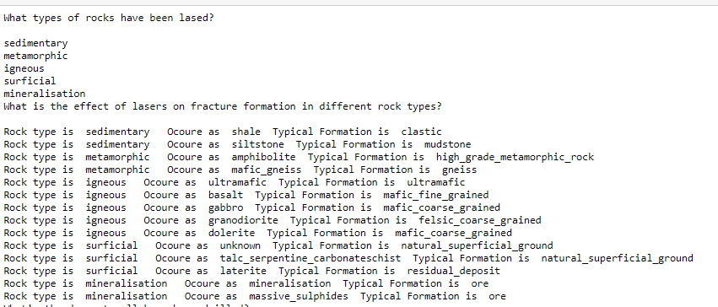

**AI Techniques in Drilling System Design and Operations**

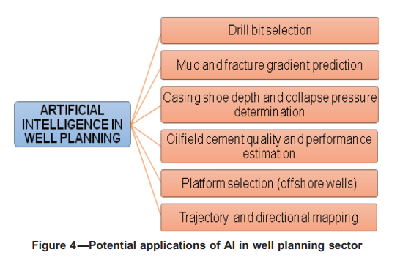

Selection of drill bits as per formation characteristics has been one of the most prospective sector benefiting by the application of AI   
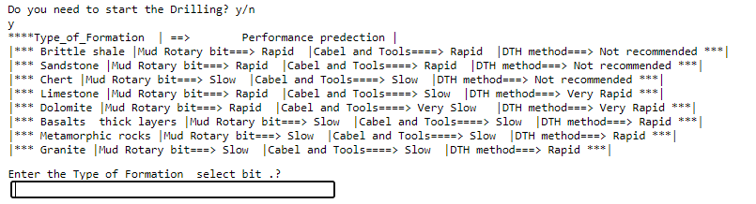

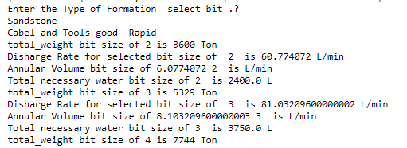

Making prediction

Selected = (input("enter Rock occur_as analysis chemical formation?\n ") or "dolerite" )

for s in p.query("occur_as(%s,Y),depth(Z,P,Y)" %Selected):

print("Depth from:",s["Z"] ," Up to: ",s["P"])

